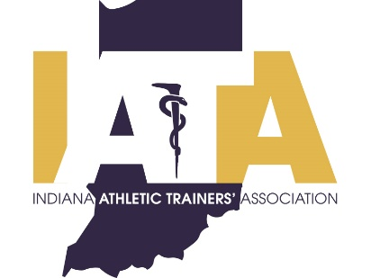 | PRESS RELEASE
 | FOR IMMEDIATE RELEASE
 | Scott Sell, Communications Chair
 | Phone: (812) 240-5098
 | scott.h.sell@gmail.com

Marques Clayton Awarded IATA Athletic Director of the Year

Indianapolis, IN (12/31/2020)---- Marques Clayton, Athletic Director at Warren Central High School has been chosen as the 2020 Athletic Director of the Year by the Indiana Athletic Trainers Association (IATA). Due to the ongoing COVID pandemic, Marques will be presented his award during a special virtual ceremony with the other members of the class.

The Indiana Athletic Trainers’ Association (IATA) will honor District Athletic Director at Warren Central High School, MSD Warren Township, Marques Clayton with the IATA Athletic Director of the Year award. Marques is a three-time graduate of Indiana State University. He has held his position at Warren Central HS since 2009 where he has been a consistent advocate for the athletic training staff and the health of the student athletes.

Formal Criteria for the IATA Athletic Director of the Year
The IATA Athletic Director of the Year Award is given to an athletic director who has shown professional support to athletic training in an exceptional and inspiring way. To be eligible he or she must have at least 5 years of service as an athletic director in Indiana and should be enthusiastic and have a positive attitude and dedication to the athletic training profession. For more information visit http://www.iata-usa.org/.

####

About the IATA: The Indiana Athletic Trainers' Association is committed to the provision of quality healthcare for the physically active individual and strives to advance the athletic training profession. For more information please visit www.iata-usa.org

