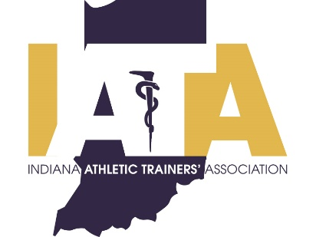 | PRESS RELEASE
 | FOR IMMEDIATE RELEASE
 | Scott Sell, Communications Chair
 | Phone: (812) 240-5098
 | scott.h.sell@gmail.com

Doug Boersma, MS, ATC Awarded IATA Professional Excellence Award

Indianapolis, IN (12/31/2020)---- Purdue athletic trainer Doug Boersma will be awarded the Indiana Athletic Trainers Association Professional Excellence award as part of the 2020 Class. Due to the ongoing COVID pandemic, Doug will be presented his award during a special virtual ceremony with the other members of the 2020 award class.

The Indiana Athletic Trainer’s Association (IATA) will honor Purdue University’s Associate Athletics Director of Sports Performance and Sports Medicine, Doug Boersma with the IATA Professional Excellence Award. In his current role Doug supervises and coordinates care for Purdue athletes amongst physicians, sports psychologists, nutritionists, strength and conditioning staff, and athletic trainers. Doug also serves as chair of the Big Ten Sports Medicine Committee advising the conference on all matters of student athlete health and safety.

Formal Criteria for the IATA Professional Excellence Award
The IATA Professional Excellence Award is given to an individual who has demonstrated excellence through their work and service. To be eligible for this award a person must be an Indiana state licensed athletic trainer, be active in advancing and supporting the profession of athletic training, should make contributions to healthcare in Indiana, and be a well-respected member of their community. For more information visit http://www.iata-usa.org/.

####

The Indiana Athletic Trainers' Association is a professional membership association for athletic trainers and athletic training students in Indiana. The IATA is committed to the provision of quality healthcare for the physically active individual and strives to advance the athletic training profession. For more information please visit www.iata-usa.org

